Part 2 : Data Definition Language

1. Create database alta_online_shop

> Query : CREATE DATABASE alta_online_shop;

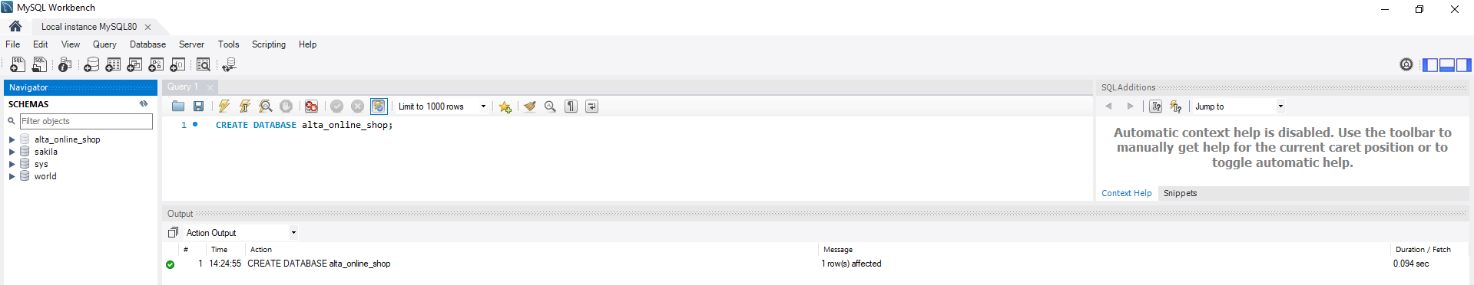

1. a. Create table user

> Query :

CREATE TABLE alta_online_shop.user (

user_id int NOT NULL AUTO_INCREMENT,

user_name varchar(255) NOT NULL,

created_date date NOT NULL,

PRIMARY KEY(user_id)

);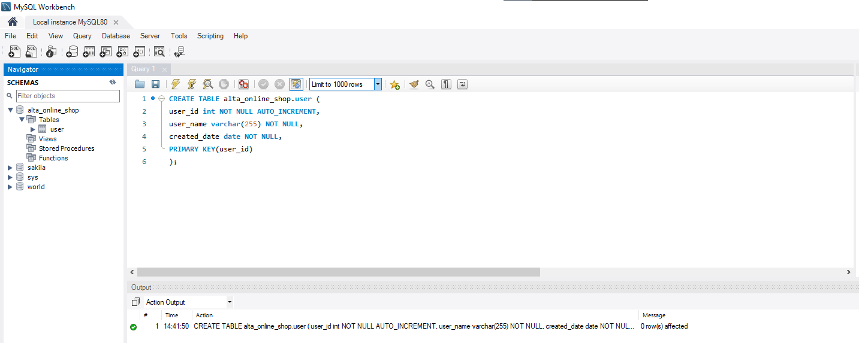

b. Create table product

> Query :

CREATE TABLE alta_online_shop.product (

product_id int NOT NULL AUTO_INCREMENT,

product_name varchar(255) NOT NULL,

product_type varchar(50),

operators varchar(255),

product_description varchar(255),

payment_method varchar(50),

created_date date NOT NULL,

updated_date date,

PRIMARY KEY(product_id)

);

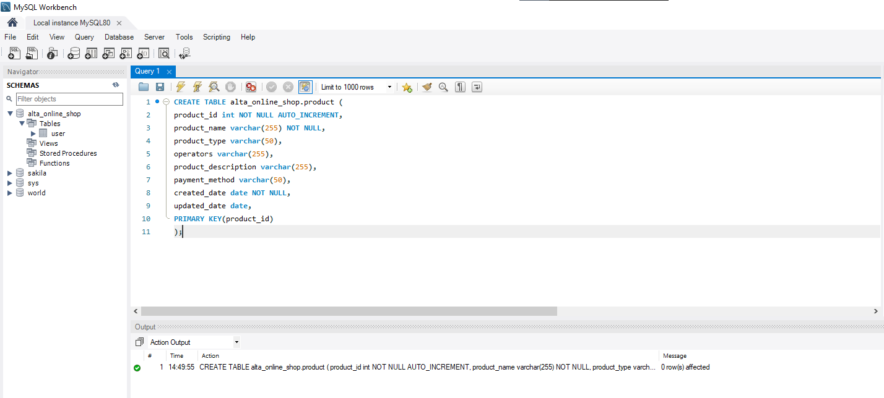

c. Create table transaction, transaction detail

> Query create table transaction :

CREATE TABLE alta_online_shop.transaction (

transaction_id int NOT NULL AUTO_INCREMENT,

product_id int NOT NULL,

user_id int NOT NULL,

transaction_no varchar(50),

transaction_date date NOT NULL,

PRIMARY KEY(transaction_id),

FOREIGN KEY (product_id) REFERENCES product(product_id),

FOREIGN KEY (user_id) REFERENCES user(user_id)

);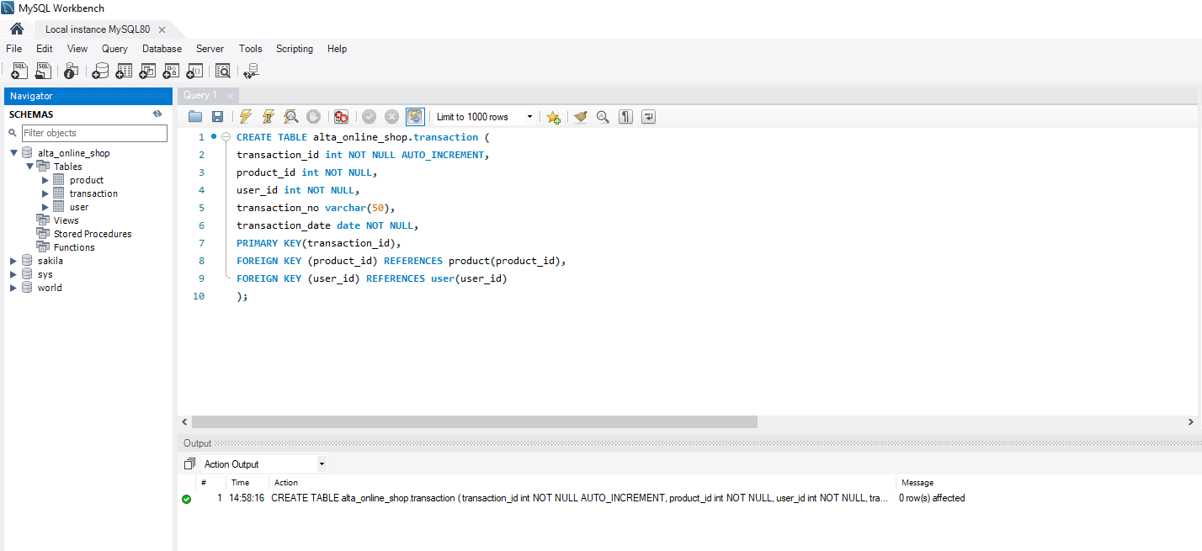

> Query create table transaction detail :

CREATE TABLE alta_online_shop.transaction_detail (

trx_detail_id int NOT NULL AUTO_INCREMENT,

transaction_id int NOT NULL,

product_id int NOT NULL,

total_item int,

PRIMARY KEY(trx_detail_id),

FOREIGN KEY (transaction_id) REFERENCES transaction(transaction_id),

FOREIGN KEY (product_id) REFERENCES product(product_id)

);

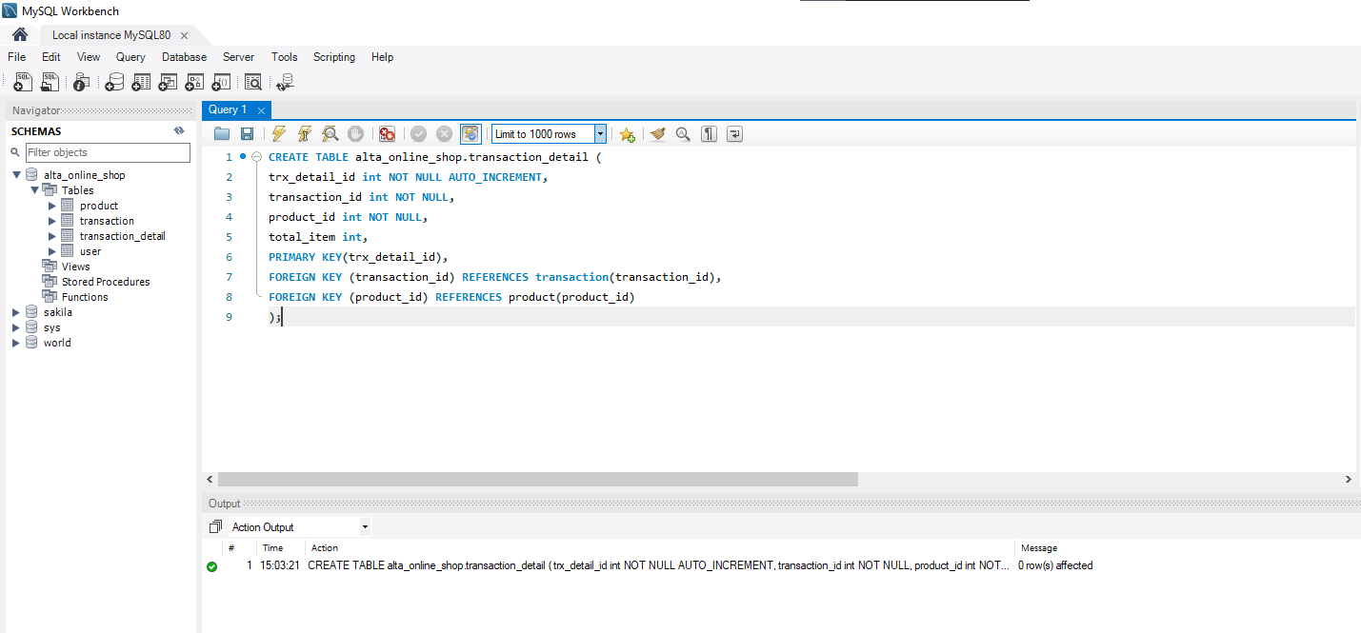

1. Create table kurir

> Query :

CREATE TABLE alta_online_shop.kurir (

kurir_id int NOT NULL AUTO_INCREMENT,

name varchar(255) NOT NULL,

created_at date NOT NULL,

updated_at date,

PRIMARY KEY(kurir_id)

);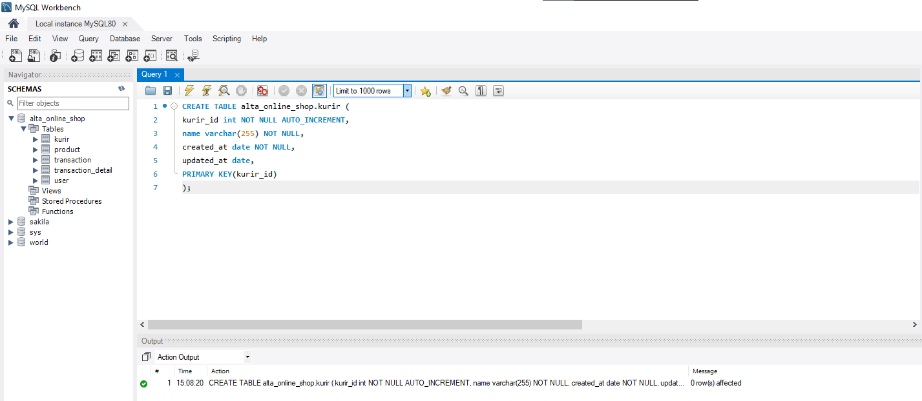

1. Tambahkan ongkos_dasar column di table kurir

> Query :

ALTER TABLE alta_online_shop.kurir

ADD ongkos_dasar double;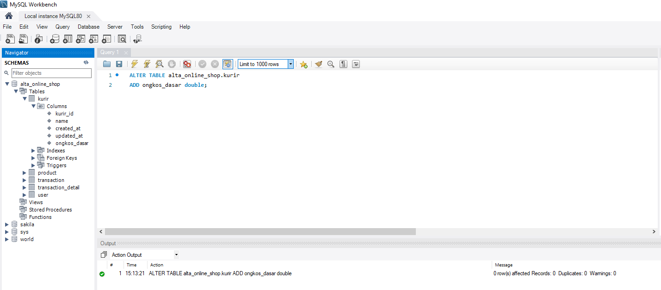

1. Rename table kurir menjadi shipping

> Query :

RENAME TABLE alta_online_shop.kurir TO alta_online_shop.shipping;

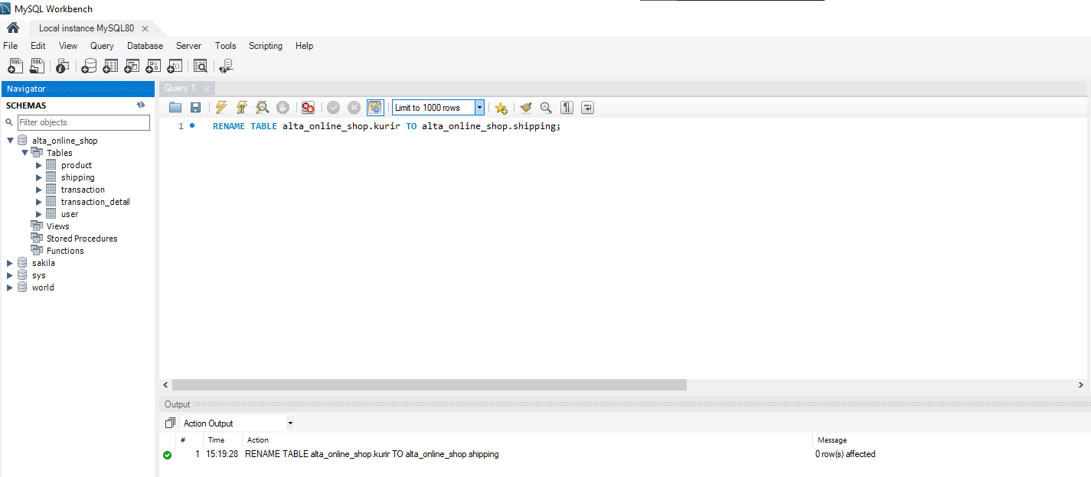

1. Hapus / Drop table shipping

> Query :

DROP TABLE alta_online_shop.shipping;

